# Ryan Timbrook

## IST 659 Data Admin Concepts &Db Mgmt

## Date: 9/3/2018

## Lab Assignment: Lab 8, Database Programming

## Description / Learning Objective

* Demonstrate proficiency in coding and using SQL Server database objects such as Functions, Views, and Stored Procedures

## Responses

### Part 1, Functions

#### P1-FUNCTIONS-TODO-1: Declaring a variable

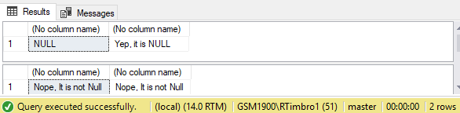

P1-FUNCTIONS-TODO-2: Code a function that counts the number of VidCasts made by a given user and returns the count to the calling code.

Questions:

* Describe what the code snippet lines 49-53 does.
  + The ‘SELECT TOP 10’ clause tells the sql server to return the first 10 records from the vc_User table ordered by the condition specified in the ‘Order BY’ clause, which in this case is the VidCastCount column listed in descending order.
  + The second clause uses our custom function to take as input the vc_UserID’s for each record and alias that column output as ‘VidCastCount’
* How does it know that the vc_User record with vc_UserID = 20 has 22 vc_VidCast records?
  + By the WHERE clause in the dbo_vc_VidCastCount function and the COUNT function on the vc_UserID input attribute that’s set as the return value for our custom function.

P1- FUNCTIONS -TODO-2: Screen Print:

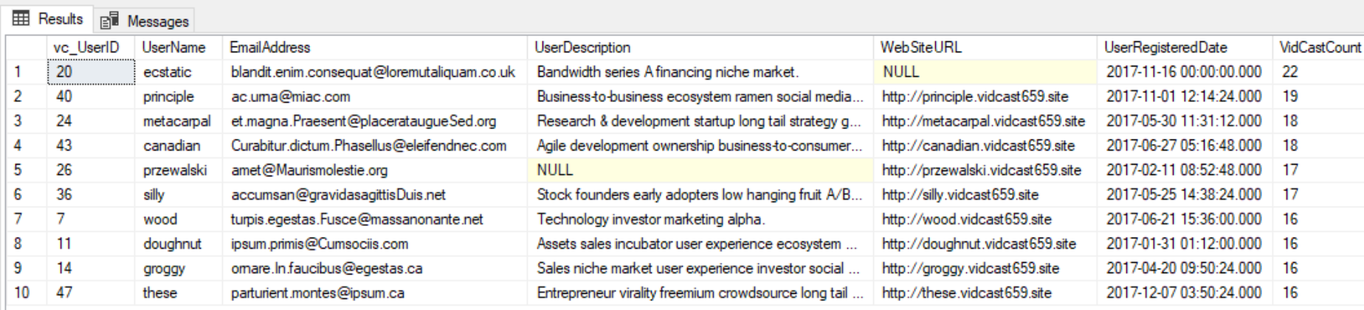

P1- FUNCTIONS -TODO-3: Code a function that accepts the tag text as a parameter and looks up the vc_tagID for the vc_tag record for that TagText

Questions:

* Describe what lines 75 and 76 do.
  + These lines use the SELECT clause to execute our custom vc_TagIDLookup function passing a string text value into the function and displaying the results from that query.
* When line 76 executed, why did we receive a NULL value from SQL Server?
  + The value, ‘Tunes’, that was passed into the function as our input text was not found in the vc_Tag table as a variable value of the TagText attribute.

P1- FUNCTIONS -TODO-3: Screen Print:

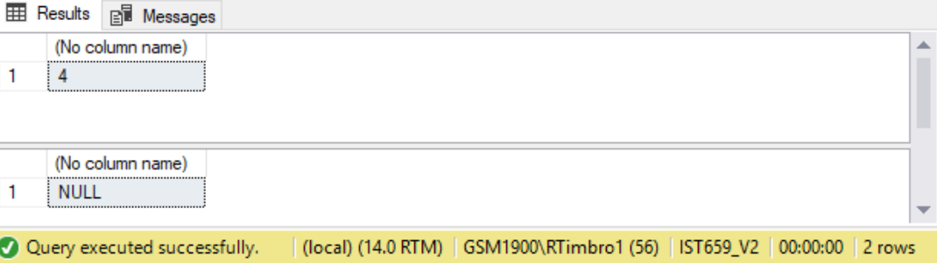

### Part 1, Views

#### P1-VIEWS-TODO-1: Create a view to retrieve the top 10 vc_Users and their VidCast counts

Questions:

* Describe what lines 79 through 87 do.
  + The code in this snippet creates a VIEW object on the SQL Server which acts like a Table object that simplifies external queries. The internal mechanics of the VIEW utilizes a custom function written earlier that returns a filtered data set of the top 10 VidCastCount records of the vc_VidCast table in descending order.

P1-VIEWS-TODO-1: Screen Print

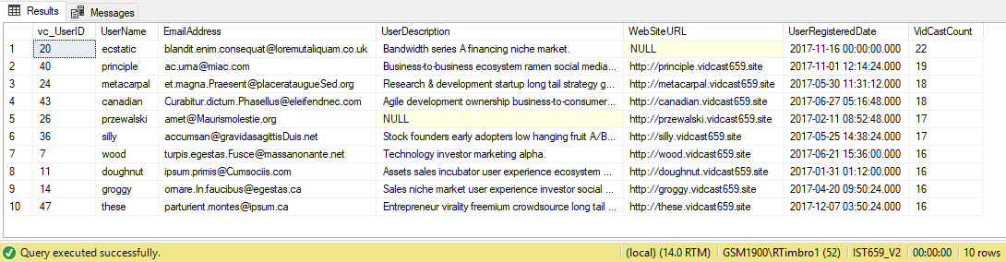

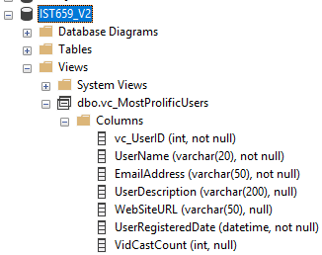

### Part 1, Stored Procedures

P1-STORED_PROCEDURES-TODO-1: Create a procedure to update a vc_User’s email address

Questions:

* Describe what lines 91 through 104 of assignments doc are doing.
  + This snippet of code creates an executable Stored Procedure on the SQL Server. The procedure is used to Update the vc_User table records based on the input parameters passed into it. Specifically, it will update the EmailAddress value in records where the userName value passed into the procedure matches a record’s userName value in the vc_User table.

P1-STORED_PROCEDURES-TODO-1: Screen Prints

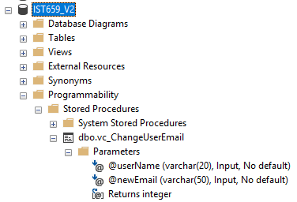

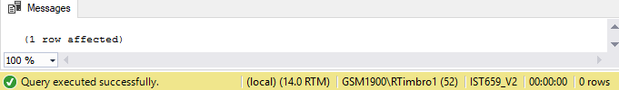

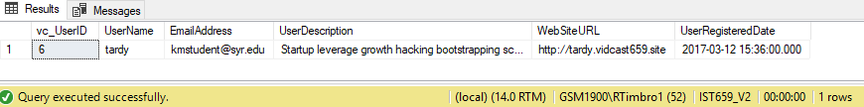

P1-STORED_PROCEDURES-TODO-2: @@identity property exercises

Questions:

* Explain why the UserLoginTimestamp is different than what’s displayed in the screen print on the assignment form.
  + This field is a datetime datatype with a default function, getdate() defined on it.
    - When a new record is added to the vc_UserLogin table this UserLoginTimestamp field will auto set to the SQL servers system time.
    - The time represented will always be the date time of when we execute the stored procedure.
* How could we simplify the code in the stored procedure?
  + ???????? Looks pretty simple, how to make it more simple it the question?

P1-STORED_PROCEDURES-TODO-2: Screen Prints

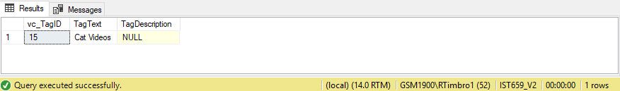

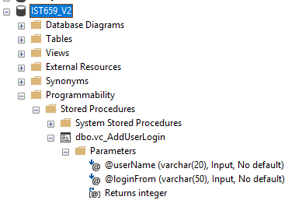

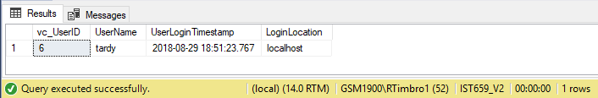

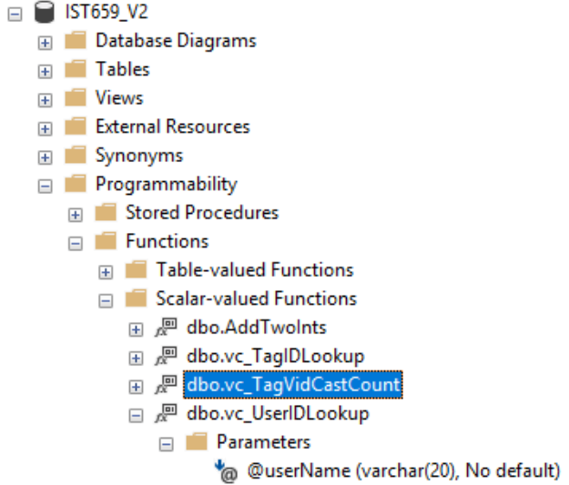

### Part 2, Putting All Together

P2-TODO-USER_DEFINED_FUNCTIONS-1: dbo.vc_UserIDLookup

Complete the code to assign the correct vc_UserID to @returnValue

P2-TODO-USER_DEFINED_FUNCTIONS-1: Screen Prints

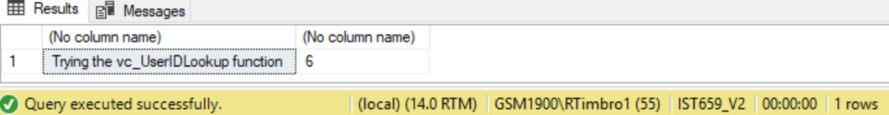

P2-TODO-USER_DEFINED_FUNCTIONS-2: dbo.vc_TagVidCastCount

Create a function that calculates the count of vc_VidCastIDs for a given vc_TagID

P2-TODO-USER_DEFINED_FUNCTIONS-2: Screen Prints

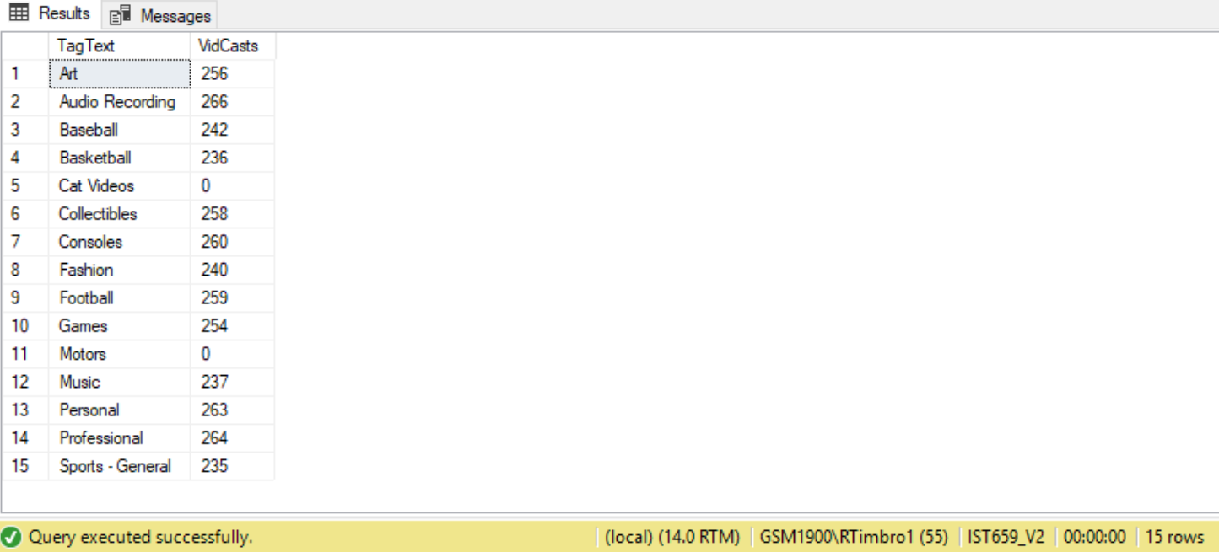

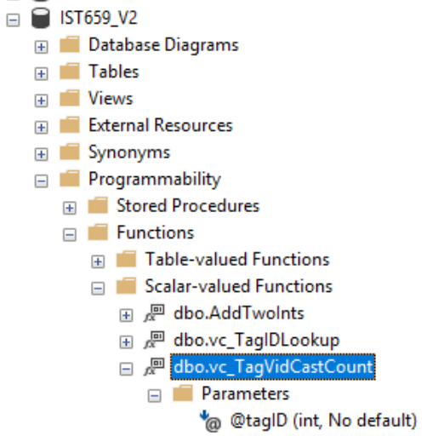

P2-TODO-USER_DEFINED_FUNCTIONS-3: dbo.vc_VidCastDuration

Create a function that SUMs the total number of minutes of actual duration for VidCasts with a Finished status given a vc_UserID as a parameter.

Returns the SUM as an int.

P2-TODO-USER_DEFINED_FUNCTIONS-3: Screen Prints

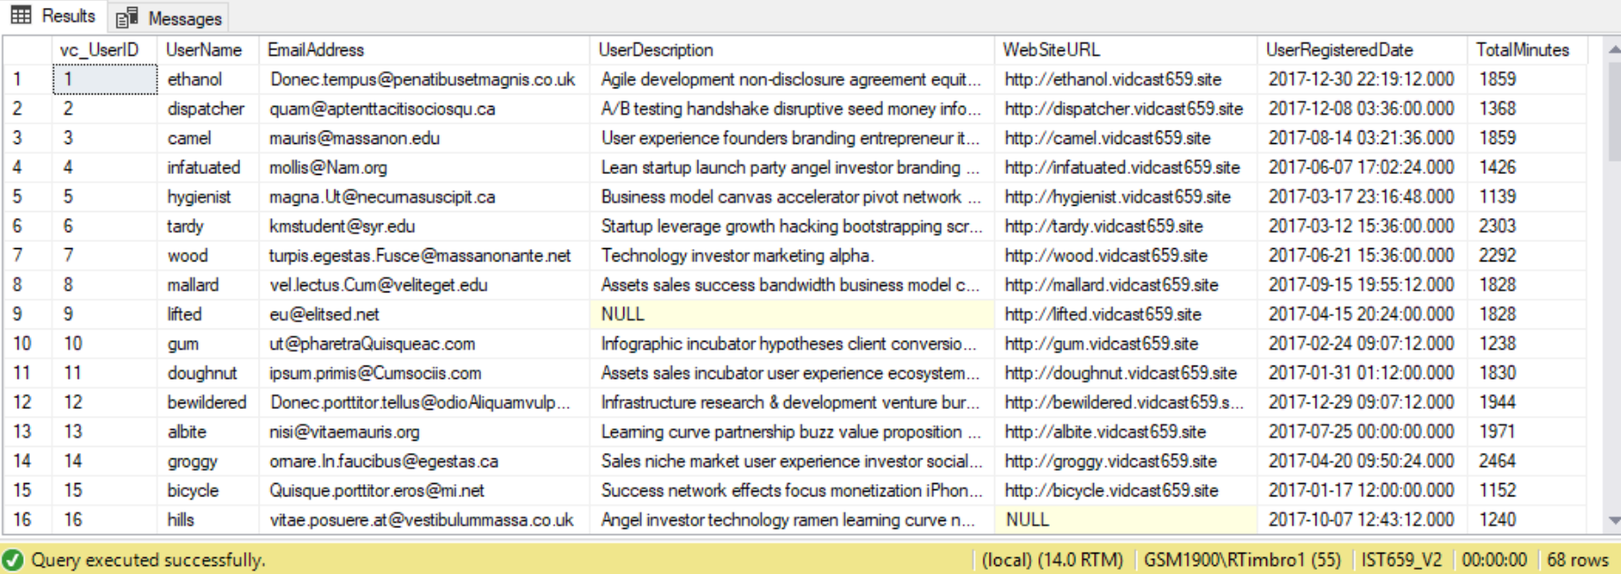

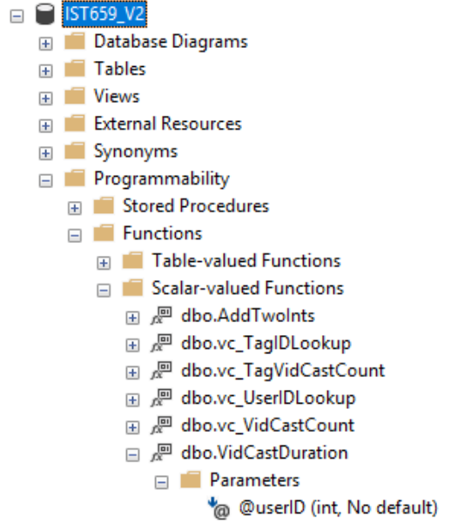

P2-TODO-VIEWS-1: Create VIEW vc_TagReport

Create a view that executes a select statement that returns a list of TagText and VidCasts count in descending order.

*Note: Had to use the OFFSET command in the ORDER BY clause to order the return data set in descending order.

P2-TODO-VIEWS-1: Screen Prints

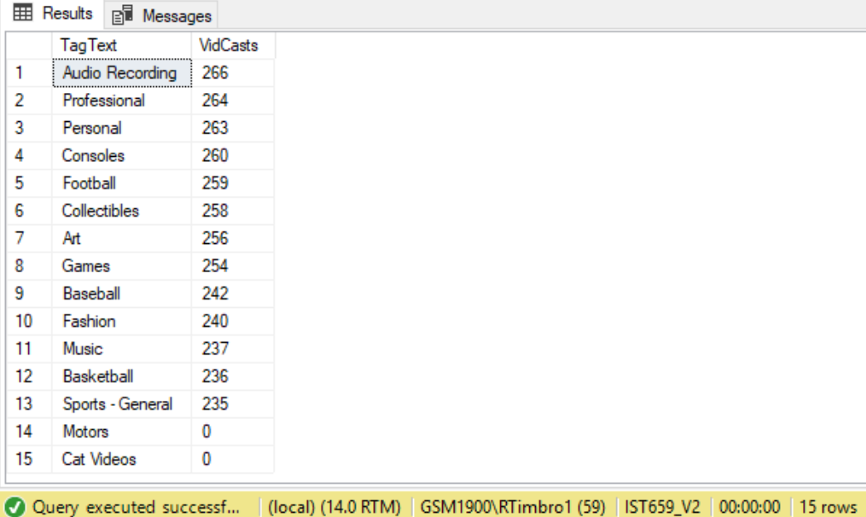

P2-TODO-VIEWS-2: Alter VIEW vc_MostProlificUsers

Alter the view vc_MostProlificUsers, add a column called TotalMinutes that calls the vc_VidCastDuration function.

P2-TODO-VIEWS-2: Screen Prints

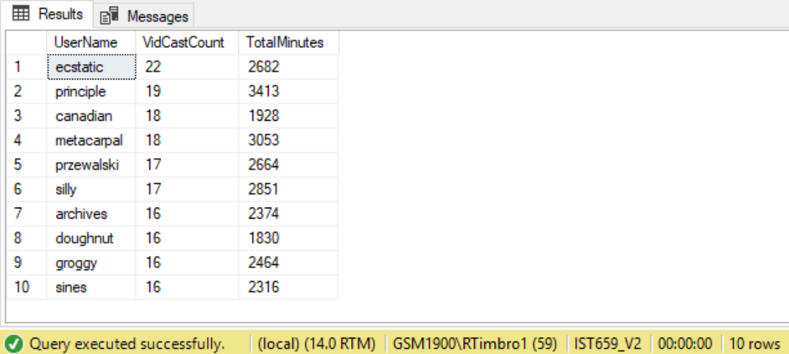

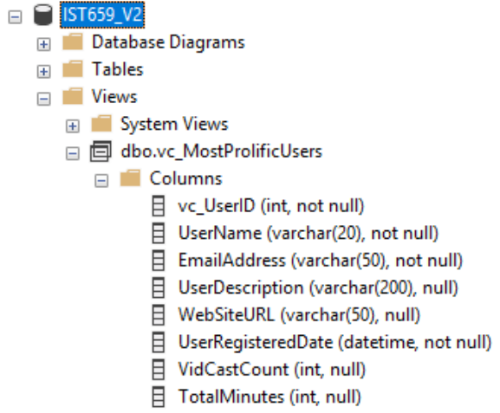

P2-TODO-STORED_PROCEDURE-1: Create procedure vc_AddTag

Create a stored procedure to use in adding a row to the vc_Tag table.

Inputs:

@tagText: the text of the new tag

@description: a brief description of the tag (nullable)

Returns:

@@identity with the value inserted

P2-TODO- STORED_PROCEDURE -1: Screen Prints

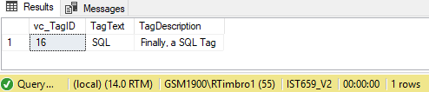

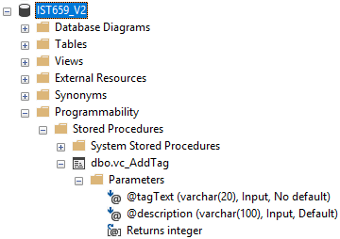

P2-TODO- STORED_PROCEDURE -2: vc_FinishVidCast

Create a stored procedure that accepts an int as a parameter that will be a vc_VidCastID that we need to mark as finished.

P2-TODO- STORED_PROCEDURE -2: Screen Prints

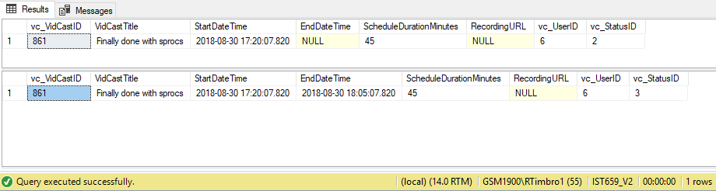

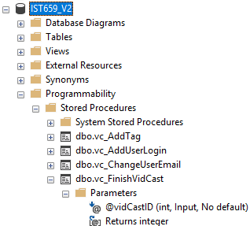

### Final SQL Script Submission:

|  |
| --- |
| /*  IST 659 Data Admin Concepts &Db Mgmt  Date: 9/3/2018  Lab Assignment: Lab 8, Database Programming  */  -- Declare a variable, @ is mandatory at the beginning of the variable name in SQL Server  declare @isThisNull varchar(30) -- starts out as NULL  Select @isThisNull, ISNULL(@isThisNull,'Yep, it is NULL')  -- Set the variable to something  SET @isThisNull = 'Nope, It is not Null'  SELECT @isThisNull, ISNULL(@isThisNull, 'Yep, it is null')  GO  /*  First User Defined Function  */  CREATE FUNCTION dbo.AddTwoInts(@firstNumber int, @secondNumber int)  RETURNS int AS -- AS is the keyword that ends the CREATE FUNCTION clause  BEGIN  -- First, delcare the variable to temporarily hold the results  DECLARE @returnValue int -- the data type matches the "RETURN" clause  -- Set the variable to the correct value  SET @returnValue = @firstNumber + @secondNumber  -- Return the value to the calling statement  RETURN @returnValue  END  GO  -- TODO: Execute SQL Select statement against new function  SELECT dbo.AddTwoInts(5,10)  /*  TODO: Code a function that counts the number of VidCasts made by a given user  and returns the count to the calling code  */  -- Drop Function if it Exists  GO  IF EXISTS  (SELECT * FROM sys.objects  WHERE object_id=OBJECT_ID(N'dbo.vc_VidCastCount')  AND type in (N'FN',N'IF',N'TF',N'FS',N'FT'))  DROP FUNCTION dbo.vc_VidCastCount  GO  -- Function to count the VidCasts made by a given User  GO  CREATE FUNCTION dbo.vc_VidCastCount(@userID int)  RETURNS int AS -- COUNT() is an integer value, so return it as an int  BEGIN  DECLARE @returnValue int -- matches the function's return type  /*  Get the count of the VidCasts for the provided userID and  assign that value to @returnValue. Note that we use the  @userID parameter in the WHERE clause to limit our count  to that user's VidCast records.  */  SELECT @returnValue = COUNT(vc_UserID) FROM vc_VidCast  WHERE vc_VidCast.vc_UserID = @userID  -- Return @returnValue to the calling code  RETURN @returnValue  END  GO  --  SELECT TOP 10  *,  dbo.vc_VidCastCount(vc_UserID) as VidCastCount  FROM dbo.vc_User  ORDER BY VidCastCount DESC  /*  TODO: Code a function that accepts the tag text as a parameter and looks up the vc_tagID for the vc_tag record for that TagText  */  -- Drop Function if it exists  IF EXISTS  (SELECT * FROM sys.objects  WHERE object_id=OBJECT_ID(N'dbo.vc_TagIDLookup')  AND type in (N'FN',N'IF',N'TF',N'FS',N'FT'))  DROP FUNCTION dbo.vc_TagIDLookup  GO  GO  -- Function to retrieve the vc_TagID for a given tag's text  CREATE FUNCTION dbo.vc_TagIDLookup(@tagText varchar(20))  RETURNS int AS -- vc_TagID as an int, so we'll match that  BEGIN  DECLARE @returnValue int -- Matches the function's return type  /*  Get the vc_TagID of the vc_Tag record whose TagText  matches the parameter and assign that value to @returnValue  */  SELECT @returnValue = vc_TagID  FROM vc_Tag  WHERE TagText = @tagText  -- Send the vc_TagID back to the caller  RETURN @returnValue  END  GO  -- Test dbo.vc_TagIDLookup function  SELECT dbo.vc_TagIDLookup('Music')  SELECT dbo.vc_TagIDLookup('Tunes')  /*  Views  */  -- TODO: Create a view to retrieve the top 10 vc_Users and their VidCast counts  -- Drop VIEW if it exists  IF EXISTS  (SELECT * FROM sys.views  WHERE name = 'vc_MostProlificUsers' AND schema_id = SCHEMA_ID('dbo'))  DROP VIEW dbo.vc_MostProlificUsers  GO  CREATE VIEW vc_MostProlificUsers AS  SELECT TOP 10  *  , dbo.vc_VidCastCount(vc_UserID) as VidCastCount  FROM vc_User  ORDER BY VidCastCount DESC  GO  -- Test the vc_MostProlificUsers VIEW  SELECT * FROM vc_MostProlificUsers  /*  Stored Procedures  */  -- TODO: Create a procedure to update a vc_User's email address  -- The first parameter is the user name for the user to change  -- The second is the new email address  -- First DELETE the Stored Procedure if it exists  DROP PROCEDURE IF EXISTS vc_ChangeUserEmail  GO  CREATE PROCEDURE vc_ChangeUserEmail(@userName varchar(20), @newEmail varchar(50))  AS  BEGIN  UPDATE vc_User SET EmailAddress = @newEmail  WHERE userName = @userName  END  GO  -- Test the above Stored Procedure  EXEC vc_ChangeUserEmail 'tardy','kmstudent@syr.edu'  -- To see the effect from running the above execution of the vc_ChangeUserEmail Stored Procedure  -- run this snippet  SELECT * FROM vc_User WHERE UserName = 'tardy'  -- @@identity  -- TODO: Add a new record to the vc_Tag table and run a query using the @@identity property  INSERT INTO vc_Tag(TagText) VALUES('Cat Videos')  SELECT * FROM vc_Tag WHERE vc_TagID = @@identity  -- TODO: Create a stored procedure to return the @@identity property  /*  Create a procedure that adds a row to the UserLogin table  This procedure is run when a user logs in and we need to record  who they are and from where the're logging in.  */  -- First Drop procedure if exists  DROP PROCEDURE IF EXISTS vc_AddUserLogin  GO  CREATE PROCEDURE vc_AddUserLogin(@userName varchar(20),@loginFrom varchar(50))  AS  BEGIN  -- we have the user name, but we need the ID for the login table  -- First, declare a variable to hold the ID  DECLARE @userID int  -- Get the vc_UserID for the UserName provided and store it in @userID  SELECT @userID = vc_UserID FROM vc_User  WHERE UserName = @userName  -- Now we can add the row using an INSERT statement  INSERT INTO vc_UserLogin(vc_UserID, LoginLocation)  VALUES (@userID, @loginFrom)  -- New return the @@identity so the calling code knows where the data end up  RETURN @@identity  END  GO  -- Test the vc_AddUserLogin procedure by executing the below snippet  DECLARE @addedValue int  EXEC @addedValue = vc_AddUserLogin 'tardy', 'localhost'  SELECT  vc_User.vc_UserID,  vc_User.UserName,  vc_UserLogin.UserLoginTimestamp,  vc_UserLogin.LoginLocation  FROM vc_User  JOIN vc_UserLogin on vc_User.vc_UserID = vc_UserLogin.vc_UserID  WHERE vc_UserLoginID = @addedValue  /*  HOW DO WE MAKE THE AddUserLogin PROCEDURE SIMPLER????  */  /*  #### PART 2 - Putting All Together ####  */  /*  Create a function to retrieve a vc_UserID for a given user name  P2-TODO-USER_DEFINED_FUNCTIONS-1: dbo.vc_UserIDLookup  */  -- Drop Function if it exists  IF EXISTS  (SELECT * FROM sys.objects  WHERE object_id=OBJECT_ID(N'dbo.vc_UserIDLookup')  AND type in (N'FN',N'IF',N'TF',N'FS',N'FT'))  DROP FUNCTION dbo.vc_UserIDLookup  GO  -- CREATE user-defined function  CREATE FUNCTION dbo.vc_UserIDLookup(@userName varchar(20))  RETURNS int AS  BEGIN  DECLARE @returnValue int  -- TODO: Code to assign the correct vc_UserID to @returnValue  SELECT @returnValue = vc_UserID FROM vc_User  WHERE UserName = @userName  -- Return the vc_UserID found from the input attribute @userName  RETURN @returnValue  END  GO  -- Test the user-defined function dbo.vc_UserIDLookup  SELECT 'Trying the vc_UserIDLookup function', dbo.vc_UserIDLookup('tardy')  /*  Create a function that calculates the count of vc_VidCastIDs for a given vc_TagID  P2-TODO-USER_DEFINED_FUNCTIONS-2: dbo.vc_TagVidCastCount  */  -- Drop Function if it exists  IF EXISTS  (SELECT * FROM sys.objects  WHERE object_id=OBJECT_ID(N'dbo.vc_TagVidCastCount')  AND type in (N'FN',N'IF',N'TF',N'FS',N'FT'))  DROP FUNCTION dbo.vc_TagVidCastCount  GO  -- CREATE user-defined function  GO  CREATE FUNCTION dbo.vc_TagVidCastCount(@tagID int)  RETURNS int AS  BEGIN  DECLARE @returnValue int  -- Count vc_VidCastIDs for a given tagID from the vc_VidCastTagList table  SELECT @returnValue = COUNT(vc_VidCastID) FROM vc_VidCastTagList  WHERE vc_VidCastTagList.vc_TagID = @tagID  -- Retrun the count of vc_VidCastIDs  RETURN @returnValue  END  GO  -- Test the user-defined function dbo.vc_TagVidCastCount  SELECT vc_Tag.TagText, dbo.vc_TagVidCastCount(vc_Tag.vc_TagID) as VidCasts  FROM vc_Tag  /*  Create a function that SUMs the total number of minutes of actual duration for VidCasts  with a Finished status given a vc_UserID as a parameter.  -> Returns the SUM as an int  P2-TODO-USER_DEFINED_FUNCTIONS-3: dbo.vc_VidCastDuration  */  -- Drop Function if it exists  IF EXISTS  (SELECT * FROM sys.objects  WHERE object_id=OBJECT_ID(N'dbo.vc_VidCastDuration')  AND type in (N'FN',N'IF',N'TF',N'FS',N'FT'))  DROP FUNCTION dbo.vc_VidCastDuration  GO  -- CREATE user-defined function  CREATE FUNCTION dbo.VidCastDuration(@userID int)  RETURNS int AS  BEGIN  DECLARE @returnValue int  --  SELECT @returnValue = SUM(DATEDIFF(n,vc_VidCast.StartDateTime, vc_VidCast.EndDateTime))  FROM vc_VidCast  JOIN vc_Status on vc_Status.vc_StatusID = vc_VidCast.vc_StatusID  WHERE vc_VidCast.vc_UserID = @userID  AND vc_Status.StatusText = 'Finished'    -- Return the SUM of duration of VidCasts  RETURN @returnValue  END  GO  -- UNIT TEST: REMOVE BELOW SNIPPET  SELECT SUM(DATEDIFF(n,vc_VidCast.StartDateTime, vc_VidCast.EndDateTime)) as TotalMinutes, vc_Status.StatusText  FROM vc_VidCast  JOIN vc_Status on vc_Status.vc_StatusID = vc_VidCast.vc_StatusID  WHERE vc_VidCast.vc_UserID = 1  AND vc_Status.StatusText = 'Finished'  GROUP BY  vc_Status.StatusText  -- REMOVE ABOVE SNIPPET  -- Test the user-defined function dbo.vc_VidCastDuration  SELECT *, dbo.VidCastDuration(vc_UserID) as TotalMinutes  FROM vc_User  /*  CODING YOUR OWN VIEWS  -- Create a view that executes a SELECT statement  P2-TODO-VIEWS-1: vc_TagReport  */  -- Drop VIEW if it exists  IF EXISTS  (SELECT * FROM sys.views  WHERE name = 'vc_TagReport' AND schema_id = SCHEMA_ID('dbo'))  DROP VIEW dbo.vc_TagReport  -- Create vc_TagReport VIEW  GO  CREATE VIEW vc_TagReport AS  SELECT  vc_Tag.TagText,  dbo.vc_TagVidCastCount(vc_Tag.vc_TagID) as VidCasts  FROM vc_Tag  ORDER BY VidCasts DESC OFFSET 0 ROWS -- Use the OFFSET command set to 0 otherwise SQL server won't allow the Order By Clause  GO  -- Test the vc_TagReport VIEW  SELECT * FROM vc_TagReport  /*  CODING YOUR OWN VIEWS  -- Alter the view vc_MostProlificUsers, add a column called totalMinutes that calls the  vc_VidCastDuration function  -- P2-TODO-VIEWS-2: vc_MostProlificUsers  */  GO  ALTER VIEW vc_MostProlificUsers AS  SELECT TOP 10  *  , dbo.vc_VidCastCount(vc_UserID) as VidCastCount  , dbo.VidCastDuration(vc_UserID) as TotalMinutes  FROM vc_User  ORDER BY VidCastCount DESC  GO  -- Test the vc_MostProlificUsers view  SELECT UserName, VidCastCount, TotalMinutes FROM vc_MostProlificUsers  /*  CODING YOUR OWN STORED PROCEDURES  -- Create a stored procedure to use in adding a row to the vc_Tag table.  Inputs:  @tagText: the text of the new tag  @description: a brief description of the tag (nullable)  Returns:  @@identity with the value inserted  -- P2-TODO-STORED_PROCEDURE-1: vc_AddTag  */  -- First DELETE the Stored Procedure if it exists  DROP PROCEDURE IF EXISTS vc_AddTag  -- Create the vc_AddTag procedure  GO  CREATE PROCEDURE vc_AddTag(@tagText varchar(20), @description varchar(100)=NULL) AS  BEGIN  -- Code the insert procedures here  INSERT INTO vc_Tag (vc_Tag.TagText,vc_Tag.TagDescription)  VALUES (@tagText, @description)  -- Return the @@identity property of the newley inserted record  RETURN @@identity  END  GO  -- Test the vc_AddTag stored procedure  DECLARE @newTagID int  EXEC @newTagID = vc_AddTag 'SQL', 'Finally, a SQL Tag'  SELECT * FROM vc_Tag WHERE vc_TagID = @newTagID  /*  CODING YOUR OWN STORED PROCEDURES  -- Create a stored procedure that accepts an int as a parameter that will be a  vc_VidCastID that we need to mark as finished.  -- P2-TODO-STORED_PROCEDURE-2: vc_FinishVidCast  */  -- First DELETE the Stored Procedure if it exists  DROP PROCEDURE IF EXISTS vc_FinishVidCast  -- Create Stored Procedure  GO  CREATE PROCEDURE vc_FinishVidCast(@vidCastID int) AS  BEGIN  -- Update VidCast EndDateTime  UPDATE vc_VidCast  SET vc_VidCast.EndDateTime = GETDATE(),  vc_VidCast.vc_StatusID = (SELECT vc_StatusID FROM vc_Status WHERE vc_Status.StatusText = 'Finished')  WHERE vc_VidCast.vc_VidCastID = @vidCastID    END  GO  -- Test the vc_FinishVidCast stored procedure  DECLARE @newVC int  INSERT INTO vc_VidCast  (VidCastTitle, StartDateTime, ScheduleDurationMinutes, vc_UserID, vc_StatusID)  VALUES  ('Finally done with sprocs', DATEADD(n,-45, GETDATE()), 45,  (SELECT vc_UserID FROM vc_User WHERE UserName = 'tardy'),  (SELECT vc_StatusID FROM vc_Status WHERE StatusText = 'Started'))  SET @newVC = @@identity  SELECT * FROM vc_VidCast WHERE vc_VidCastID = @newVC  EXEC vc_FinishVidCast @newVC  SELECT * FROM vc_VidCast WHERE vc_VidCastID = @newVC |